## Documentation:

Detailed Annotation and explainnation shows in Project.

See JavaDoc file in CarConfigurationServer/doc/ and CarConfigurationClient/doc/

## Explanation of Test Run:

Client:

Mar 07, 2014 9:33:00 PM org.apache.coyote.AbstractProtocolHandler start

INFO: Starting ProtocolHandler ["ajp-bio-8009"]

Mar 07, 2014 9:33:00 PM org.apache.catalina.startup.Catalina start

INFO: Server startup in 591 ms

Client is up...

Handling session with localhost:4448

Server: Please upload a txt file or Properties file

E:\cirrculum_spring\Java for Smartphone Development\submit\tingy_HW7\CarConfigurationClient\property_jetta.txt

Client: E:\cirrculum_spring\Java for Smartphone Development\submit\tingy_HW7\CarConfigurationClient\property_jetta.txt

Server: Receive the file and Create Automobile object Successfully. Please choose upload another file(u) or select model(s)

u

Client: u

Server: Please upload a txt file or Properties file

E:\cirrculum_spring\Java for Smartphone Development\submit\tingy_HW7\CarConfigurationClient\property_Ford.txt

Client: E:\cirrculum_spring\Java for Smartphone Development\submit\tingy_HW7\CarConfigurationClient\property_Ford.txt

Server: Receive the file and Create Automobile object Successfully. Please choose upload another file(u) or select model(s)

s

Client: s

After you input s in the console, please refresh the page in Eclipse or paste the link to a browser then continue.

IN <http://localhost/CarConfigurationClient/ModelServlet>

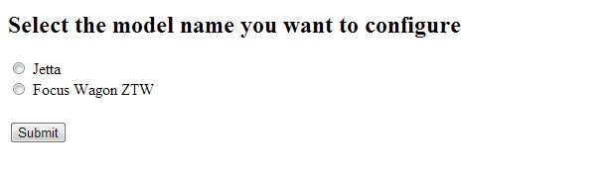

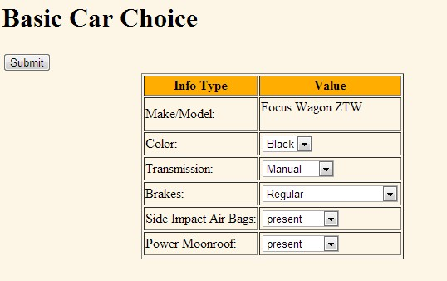

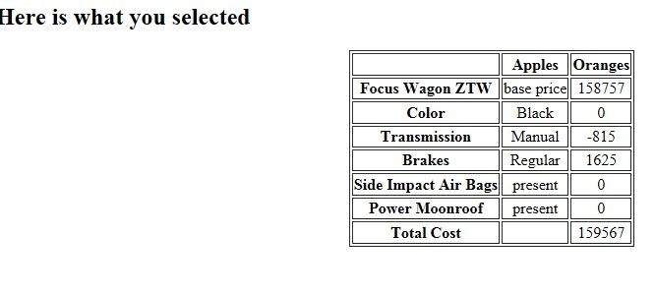

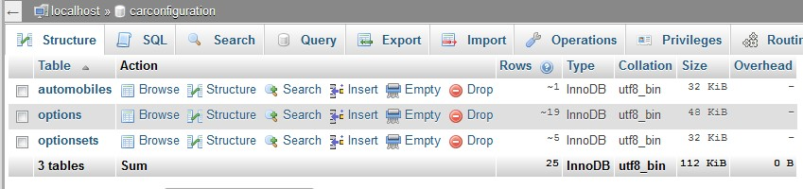

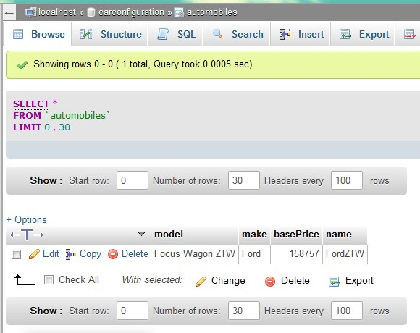

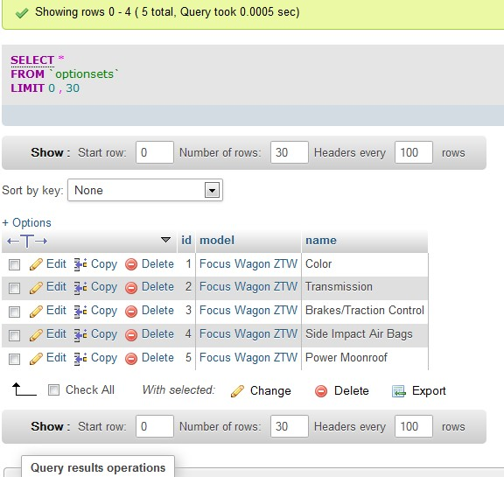

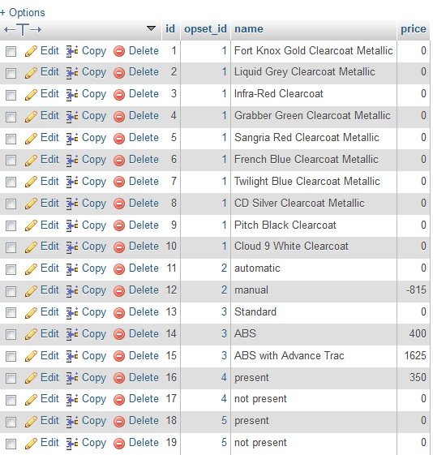

After Update:

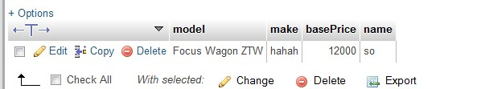

Some output:

Inserted records into the table...

OptSQL:UPDATE options SET name='red',price=200 WHERE id=1;

Inserting records into the table...

OptSQL:UPDATE options SET name='red',price=200 WHERE id=1;

createDB:UPDATE options SET name='red',price=200 WHERE id=1;

Inserted records into the table...

AutoSQL:UPDATE automobiles SET make='hahah',basePrice=12000,name='so' WHERE model='Focus Wagon ZTW';

Inserting records into the table...

AutoSQL:UPDATE automobiles SET make='hahah',basePrice=12000,name='so' WHERE model='Focus Wagon ZTW';

createDB:UPDATE automobiles SET make='hahah',basePrice=12000,name='so' WHERE model='Focus Wagon ZTW';

Inserted records into the table...

delete the Option Successfully!

OptSQL:DELETE FROM options WHERE id = 2;

Creating statement...

OptSQL:DELETE FROM options WHERE id = 2;